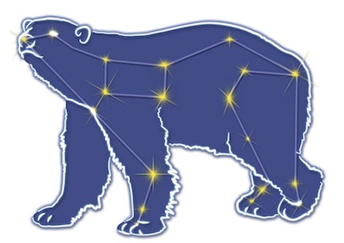
Great Bear Petroleum Operating LLC
A New Direction for the Last Frontier
601 W. 5th Ave., Suite 505, Anchorage, AK 99501
Phone: (907) 868-8070, Fax: (907) 868-3887

July 20, 2011

Ms. Cathy Foerster, Chair
Alaska Oil and Gas Conservation Commission
601 West 5th Ave., Suite 505
Anchorage, Alaska 99501

RE: Weekly Report of Operations
Great Bear Petroleum: Alcor #1 (PTD # 212-057)

Dear: Ms. Foerster,
This is a report of Great Bear Petroleum’s well operations on the Alcor #1 for the period July 13 through July 19, 2012, inclusive.

July 13, 2012 8,320’ MW 9.6 ppg Vis 130 sec Incl 2.22˚
Change BOP rams and DP handling tools to 4”. Test BOPE, test witness waived by AOGCC’s Chuck Scheve. PU 99 jts of 4” DP and RIH to 3,170’. POH, standing back DP. MU BHA #4.

July 14, 2012 8,320’ MW 10.5 ppg Vis 87 sec Incl 2.22˚
MU BHA and RIH, picking up 4” DP, to 8,091’. Displace hole to 10.5 ppg mud. Repair top drive. Pressure test casing to 3,000 psi.

July 15, 2012 8,347’ MW 10.5 ppg Vis 85 sec Incl 2.22˚
Finish csg pressure test. Replace liners in mud pumps due to excessive pumping pressure. Wash down slowly making MAD pass from 8,155’ to 8,224’. Drill shoe track, rat hole and 20’ new fm to 8,340’. Fluid losses 24 bph. CBU, perform FIT to 11.5 ppg EMW. Drill to 8,347’, fluid loss incr to 60 bph. Gas units incr to 6,000. SI well and check pressures – SICP 90 psi, SIDPP 89 psi. CBU through choke. SI – csg 80 psi, DP 130 psi. Spot 40 lb/gal LCM pill on btm.

July 16, 2012 8,347’ MW 10.5 ppg Vis 92 sec Incl 2.22˚
Open well, bleed off ½ bbl mud – well died. Monitor well, CBU – well static. POH while removing OBM from pits and cleaning pits. LD BHA, test annular to 250/2,500 psi and choke to 1,000 psi – OK. RU to outer annulus and attempt to inject w/ 3,000 psi – no success. MU BHA #5 while cleaning pits.

July 17, 2012 8,347’ MW 10.5 ppg Vis 90 sec Incl 2.22˚
Finish MU BHA #5 while cleaning pits. RIH to 8,308’. Take 9.4 ppg WBM into pits. Attempt to pump into outer annulus with 4,150 psi – no success. Displace OBM in hole with WBM and clean surf equip.

July 18, 2012 8,620’ MW 9.4 ppg Vis 90 sec Incl 5.96˚
Finish purging OBM from system. Perform second FIT (w/ WBM) to 11.5 ppg EMW. RIH, MAD pass w/ GR from 8,255’ to 8,347’. Drill 6-1/8” hole 8,347’ to 8,620’ w/ no losses. CBU for samples.

July 19, 2012 8,640’ MW 9.4 ppg Vis 78 sec Incl 8.67˚
Drill 8,620’ to 8640’, CBU for samples. POH for coring. LD BHA, MU coring assy. RIH to 8,640’ and drop ball.

If you have any questions or require additional information, please contact me at 264-6114 or 250-3113.

Sincerely,

For GREAT BEAR PETROLEUM OPERATING LLC

Bill Penrose

Drilling Manager
SolstenXP Inc.

cc: Clark Clement – Great Bear

